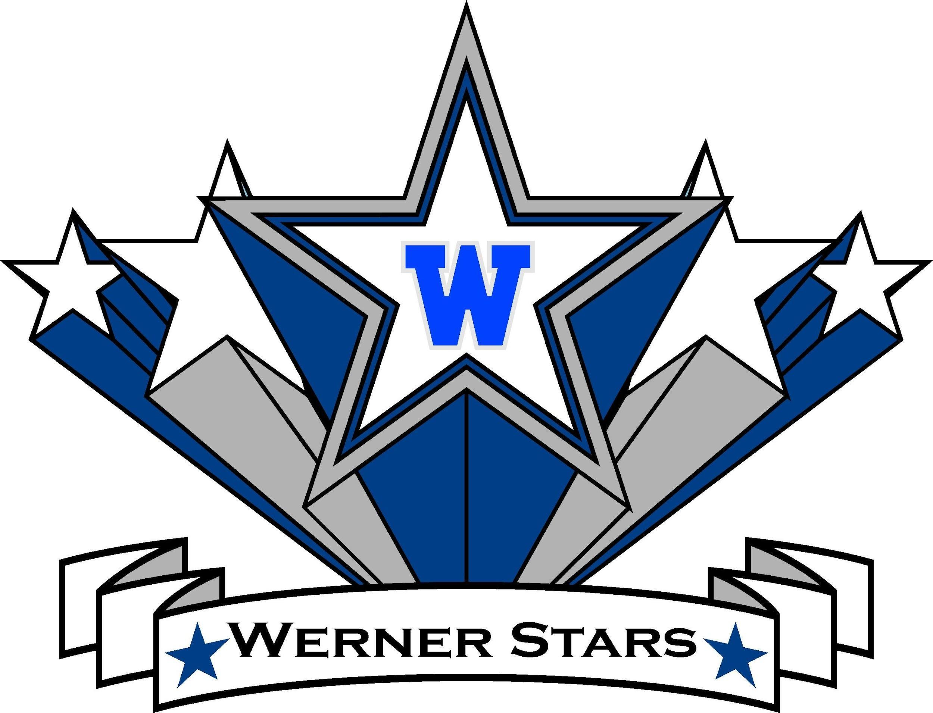
‘RIALTO UNIFIED SCHOOL DISTRICT
Dr. Cuauhtémoc Avila
Superintendent

Mrs. Tami Butler
Principal

Daniel Cuevas
Assistant Principal

Charlotte N. Werner Elementary
1050 W. RIALTO AVENUE, RIALTO, CA 92376
TELEPHONE: 909.820.6830 FAX: 909.562.0078
WEBSITE: http://werner.rialtoschools.org
EST. 2008

Parents that need special accommodations other than written translation and/or oral interpretation in Spanish, please contact the office prior to the date of the meeting.
WERNER ELEMENTARY
SCHOOL SITE COUNCIL AGENDA #2
Wednesday, October 12, 2022
2:30 p.m.

- Call to Order
- Roll Call of Members
- Additions/Deletions of Agenda Items
- Reading and Approval of Previous Meeting Minutes
- Reports of Officers/Standing and Special Committees
- DELAC October 14, 2022
- DAC November 4, 2022
- DAAPAC November 3, 2022
- Discussion Items
- Bylaws
- SPSA (The School Plan for Student Achievement)
- Information Items
- Future Meeting Dates
- Coffee with the Principal
- Celebration of Alianza Latina Event
- Raising a Reader October 7, 14, 20, 27, 2022 @ 10:00 am
- EL Awareness Week - October 3 - October 14, 2022
- Hispanic Heritage - October 10 - October 14, 2022
- Great Shake Out - October 20, 2022 @ 10:20 am
- Red Ribbon Week - October 17 - October 21, 2022
- Book Mania /Trunk or Treat - October 28, 2022 @ 5:00-7:00 pm
- Dia de los Muertos - November 02, 2022 @ 5:00 - 8:00 pm
- Public Comment (3 minutes)
- Action/Consent Items
- School Compact
- Bylaws
- Adjournment

